Assignment 4: Submission Template

Name: Daljeet Singh

Student#: 3169763

Part A: Modeling a Simple Entity using EERD
Insert an image of your completed Chen model below. You may also include any key assumptions or notes you would like understood for marking purposes.
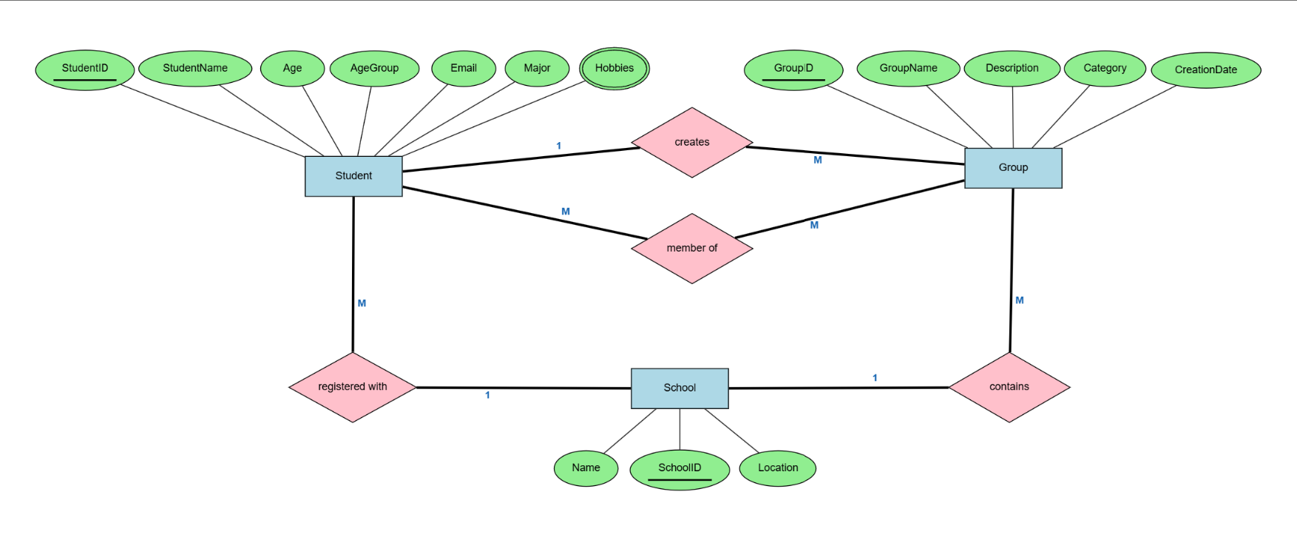

Part B: Fully Implementing a Physical Relational Database

DDL of the create table statements. | -- ACS-3902 Assignment 4 Part B  -- Name: Daljeet Singh  -- St#: 3169763  --------------------------------  CREATE SCHEMA daljeet_3169763_as4_part_b;  SET SCHEMA 'daljeet_3169763_as4_part_b';  -- School Table  CREATE TABLE School (  SchoolID int PRIMARY KEY,  Name varchar(100) NOT NULL,  Location varchar(100)  );  -- Student Table  CREATE TABLE StudentTable (  StudentID int PRIMARY KEY,  StudentName varchar(100) NOT NULL,  Age int,  AgeGroup varchar(50),  Email varchar(100) NOT NULL UNIQUE,  Major varchar(100) NOT NULL,  SchoolID int,  FOREIGN KEY (SchoolID) REFERENCES School(SchoolID)  );  -- Group Table  CREATE TABLE GroupTable (  GroupID int PRIMARY KEY,  GroupName varchar(100) NOT NULL,  Description Text,  Category varchar(100),  CreationDate Date,  SchoolID int,  FOREIGN KEY (SchoolID) REFERENCES School(SchoolID)  );  CREATE TABLE Hobbies(  StudentID int,  Hobbies text,  FOREIGN KEY (StudentID) REFERENCES StudentTable(StudentID)  );
Your DML of the insert statements to add the sample data. | --Insert into School  INSERT INTO School VALUES (1, 'DAV School', 'Ludhiana'),  (2, 'Bright School', 'Winnipeg');  -- Insert into StudentTable  INSERT INTO StudentTable VALUES (1, 'Ab de Villiers', 21 , '18-21', 'abde@gmail.com', 'Business', 1),  (2, 'Bazz' , 25, '22-25', 'bazz@gmail.com', 'Computer Science',2),  (3, 'Jack', 28, '26-29', 'jack@gmail.com', 'Agriculture',1),  (4, 'Arjan Dhillon', 29, '26-29', 'brownstudio@gmail.com', 'Music',2),  (5, 'Karan Aujla', 25, '22-25', 'rehan@gmail.com', 'Music',1);  -- Insert into GroupTable  INSERT INTO GroupTable VALUES (101, 'Cricket Enthusiasts', 'A group for cricket lovers', 'Sports', '2017-06-01',1),  (102, 'Music Lovers', 'A group for music enthusiasts', 'Music', '2019-05-15',2);  INSERT INTO Hobbies VALUES(1,'Cricket'),  (1, 'Swimming'),  (2, 'Music'),  (2, 'Cricket'),  (3, 'Sleeping'),  (4, 'Writing'),  (4, 'Riding'),  (5, 'Writing')

Part C: Partially Implementing a MongoDB NoSQL Database

Screenshot C1 | 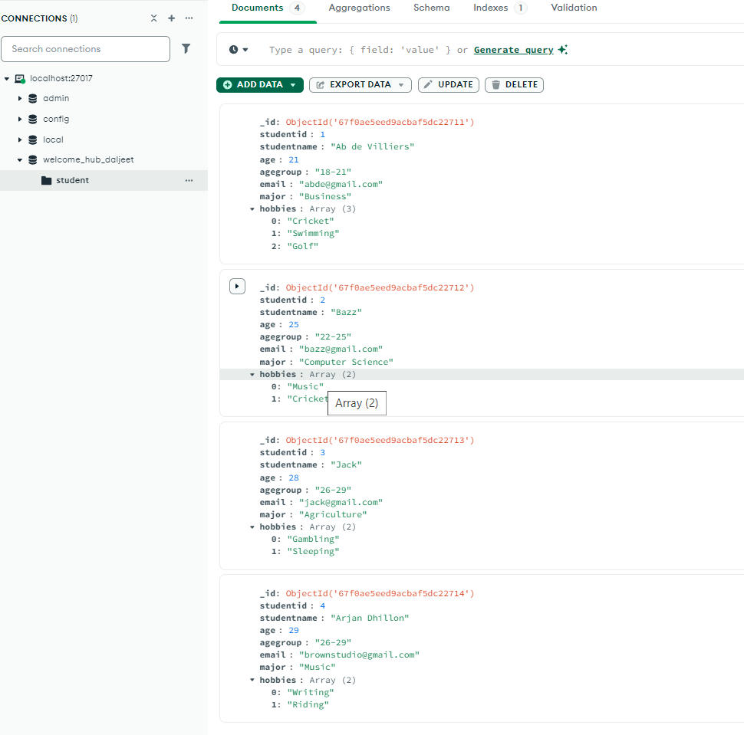
Screenshot C2 | 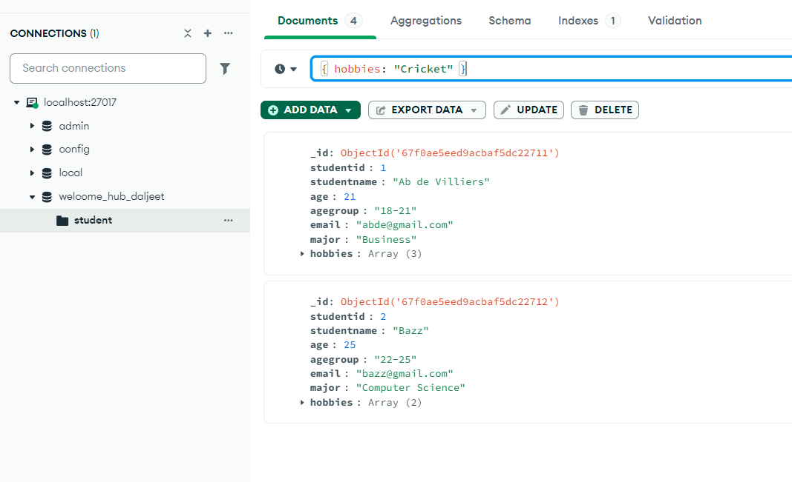
Screenshot C3 | 